Helping Hand Build Guide

Most of the components of the Helping Hand are 3D-printed and designed by us in blender and attached to each other using elastic bands or strings. There are 8 finger braces in total: 2 for each finger: one small for above the knuckle, one larger for below the knuckle. A string is threaded through a small hole in each pair of rings, and an elastic band through the second small holes (as shown below). The tips of the string and elastic closest to the tip of each finger then have knots tied onto them, securing them in place.

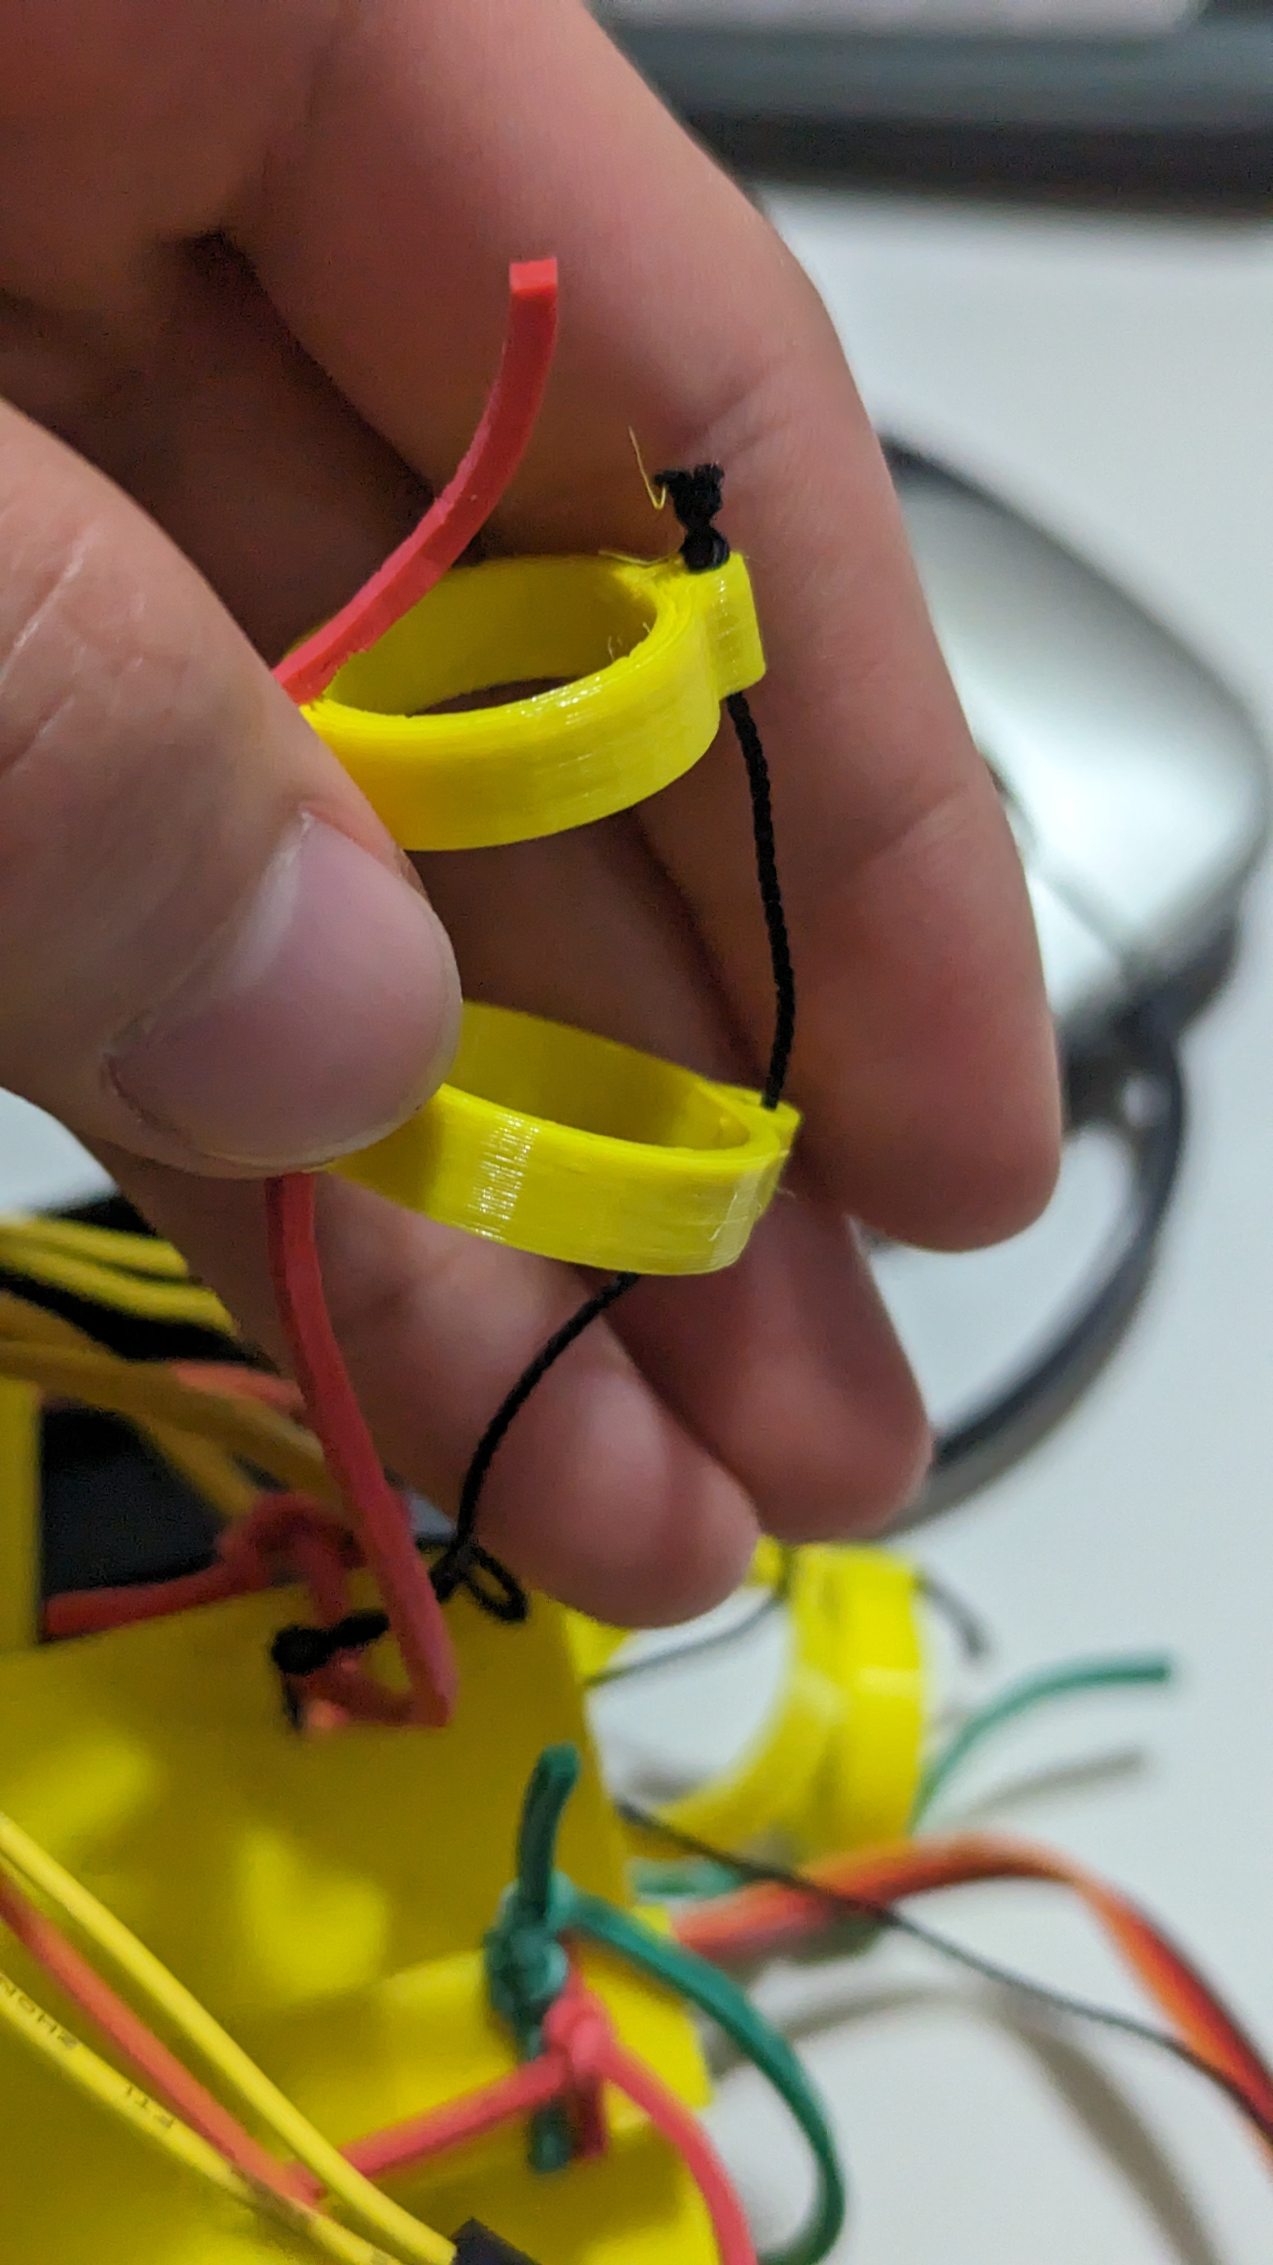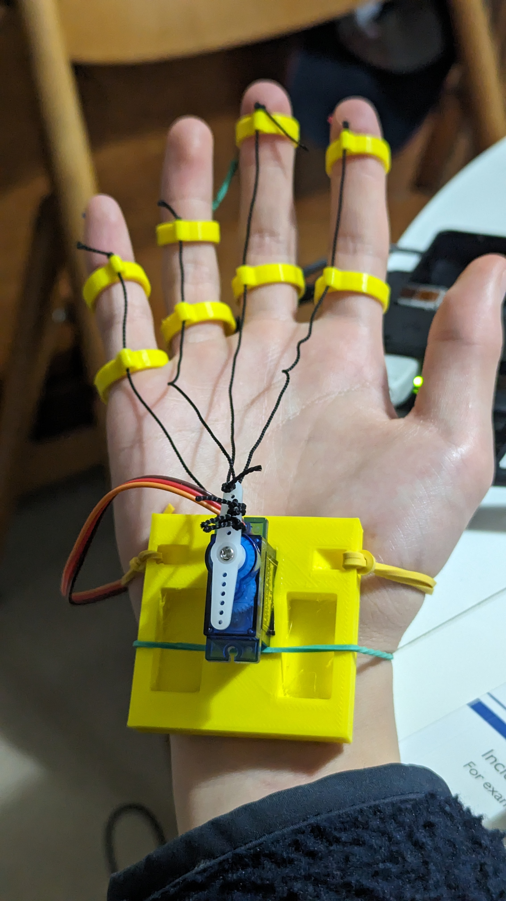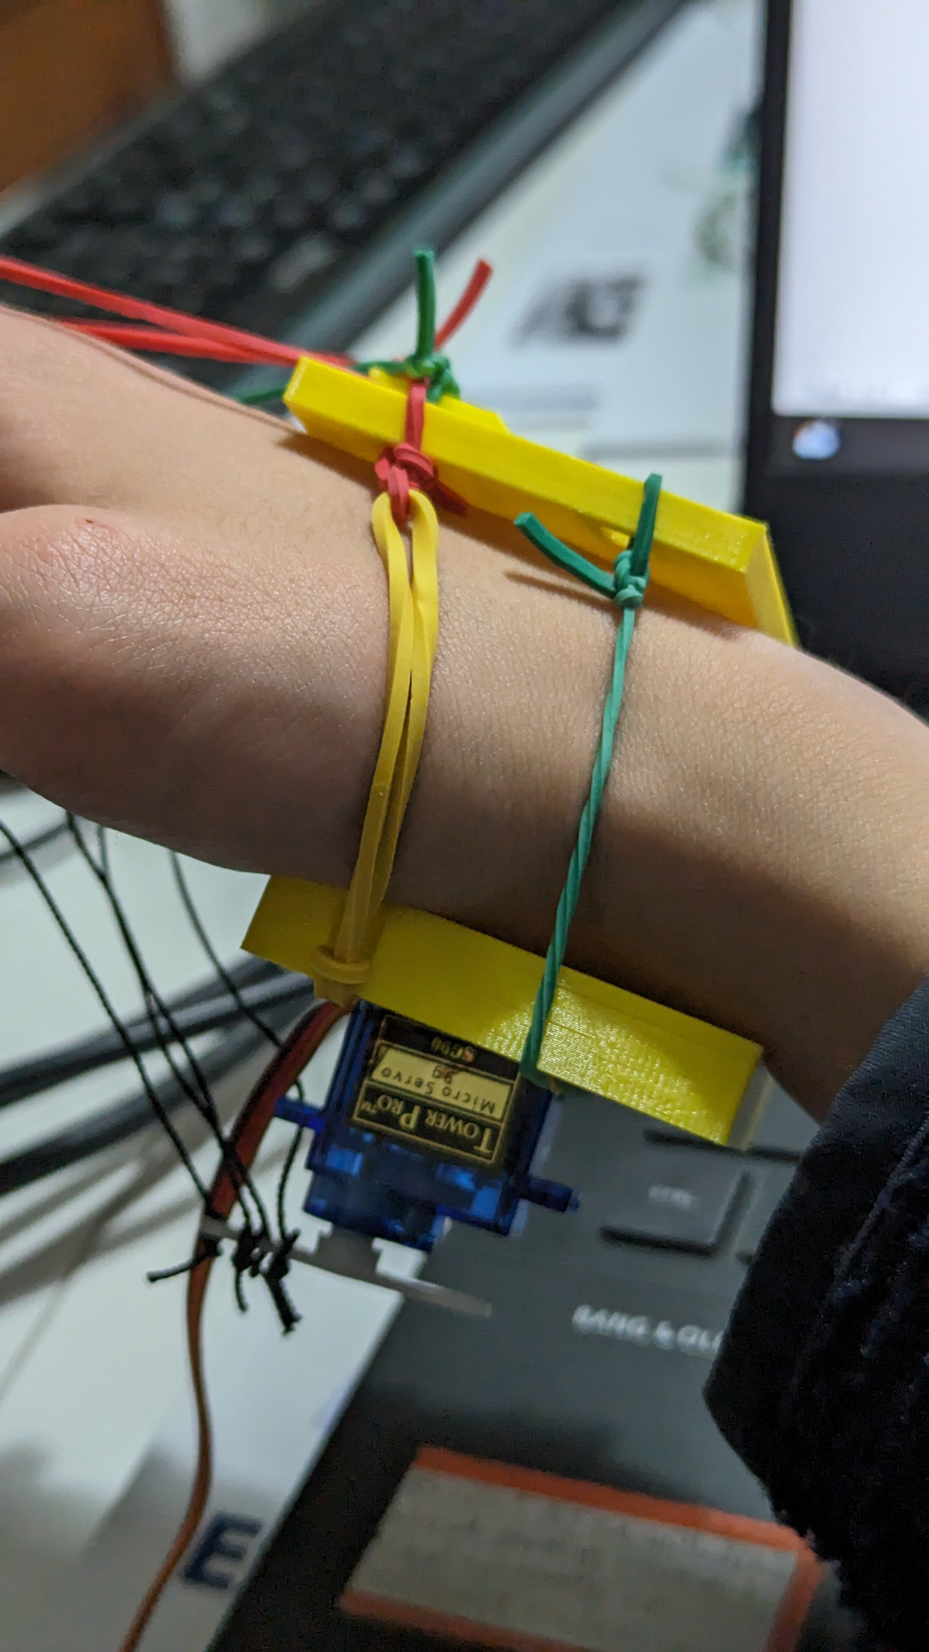

The ends of the strings are threaded through the holes in the servo arm, pulled until relatively tight and tied on. The servo is friction-fitted into a rectangular hole on the bottom plate (above) and the elastic bands are tied onto the top plate (above). The top plate and bottom plate are connected with 2 elastic bands, allowing the device to fit on a range of wrist sizes.

The servo is then wired onto a raspberry-pi. The servo shown can be bought here: <https://www.amazon.co.uk/dp/B0CGXHPTXY/>